1. Problem Statement
Calculate an employee's gross salary from basic pay, house rent allowance (HRA), and dearness allowance (DA); apply basic progressive deductions and generate a clean formatted salary statement.
2. Objectives
- Perform basic arithmetic calculations for salary components.
- Use simple conditional branches (if-else) to apply tax deductions based on salary brackets.
- Print a neat, formatted payslip output using basic print statements.
3. Assumptions
- $\text{HRA}=20\%$ of Basic Pay.
- $\text{DA}=10\%$ of Basic Pay.
- Provident Fund ($\text{PF}$) is fixed at $5\%$ of Basic Pay, and income tax is applied if gross salary exceeds a threshold limit.
4. Algorithm
- Step 1: Start the program.
- Step 2: Read Employee Name and Basic Pay from standard input.
- Step 3: Calculate $\text{HRA}=0.20×\text{Basic}$ and $\text{DA}=0.10×\text{Basic}$.
- Step 4: Calculate $\text{Gross Salary}=\text{Basic}+\text{HRA}+\text{DA}$.
- Step 5: Calculate $\text{PF}=0.05×\text{Basic}$.
- Step 6: If $\text{Gross Salary}>50000$, calculate $\text{Tax}=0.10×\text{Gross Salary}$; else $\text{Tax}=0.0$.
- Step 7: Calculate $\text{Total Deductions}=\text{PF}+\text{Tax}$ and $\text{Net Salary}=\text{Gross Salary}-\text{Total Deductions}$.
- Step 8: Display the formatted salary statement and stop.
5. Flowchart (Textual Representation)
[Start]
--> [Input Employee Name & Basic Pay]
--> [Calculate HRA, DA, Gross Salary]
--> [Calculate PF and Check Tax Eligibility]
--> [Calculate Net Salary = Gross - Total Deductions]
--> [Print Formatted Salary Statement]
--> [Stop]
6. Pseudocode
START
PRINT "Enter Employee Name:"
READ emp_name
PRINT "Enter Basic Pay:"
READ basic_pay

HRA = basic_pay * 0.20
DA = basic_pay * 0.10
gross_salary = basic_pay + HRA + DA

pf = basic_pay * 0.05
IF gross_salary > 50000 THEN
tax = gross_salary * 0.10
ELSE
tax = 0.0
ENDIF

total_deductions = pf + tax
net_salary = gross_salary - total_deductions

PRINT "--- SALARY STATEMENT ---"
PRINT emp_name, gross_salary, net_salary
STOP

7. Python Source Code

print("=== Employee Payroll System ===")

emp_name = input("Enter employee name: ")
basic_pay = float(input("Enter basic pay amount (INR): "))

hra = basic_pay * 0.20 # House Rent Allowance (20%)
da = basic_pay * 0.10 # Dearness Allowance (10%)
gross_salary = basic_pay + hra + da

pf = basic_pay * 0.05 # Provident Fund (5%)

if gross_salary > 50000:
tax = gross_salary * 0.10 # 10% tax for higher brackets
else:
tax = 0.0 # No tax for lower brackets

total_deductions = pf + tax
net_salary = gross_salary - total_deductions

print("\n" + "="*30)
print(" SALARY STATEMENT ")
print("="*30)
print("Employee Name :", emp_name)
print("Basic Pay : INR", basic_pay)
print("HRA (20%) : INR", hra)
print("DA (10%) : INR", da)
print("----------------------------")
print("Gross Salary : INR", gross_salary)
print("----------------------------")
print("Provident Fund : INR", pf)
print("Income Tax : INR", tax)
print("Total Deductions: INR", total_deductions)
print("="*30)
print("Net Take-Home : INR", net_salary)
print("="*30)
8. Test Cases
- Test Case 1 (Lower Bracket): Basic Pay = $30,000$ $→$ Gross = $39,000$, Tax = $0.0$, Net = $37,500$.
- Test Case 2 (Higher Bracket): Basic Pay = $45,000$ $→$ Gross = $58,500$, Tax = $5,850$, Net = $50,400$.
9. Output Screenshot
=== Employee Payroll System ===
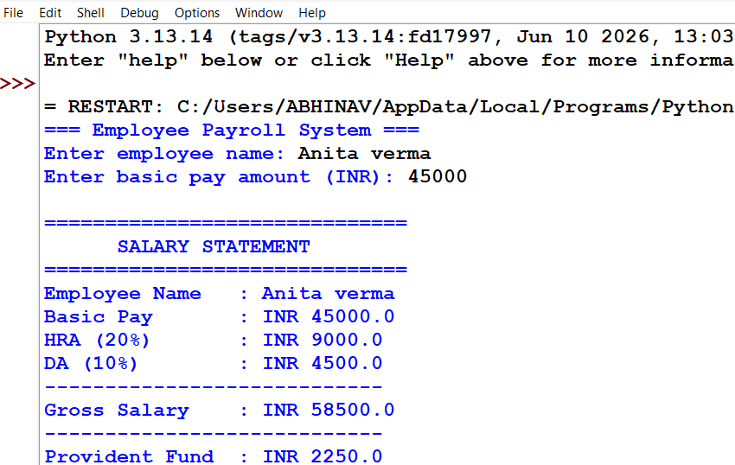

Conclusion: Successfully automated the payroll calculation process by computing gross salary, earnings allowances, and progressive deductions (such as provident fund and taxes) to output a formatted employee statement

